**3rd video task , of wedneday 12 feb app server and web server**

**Install Apache and run Apache on port number 82**

**Using the apache display the static display ….**

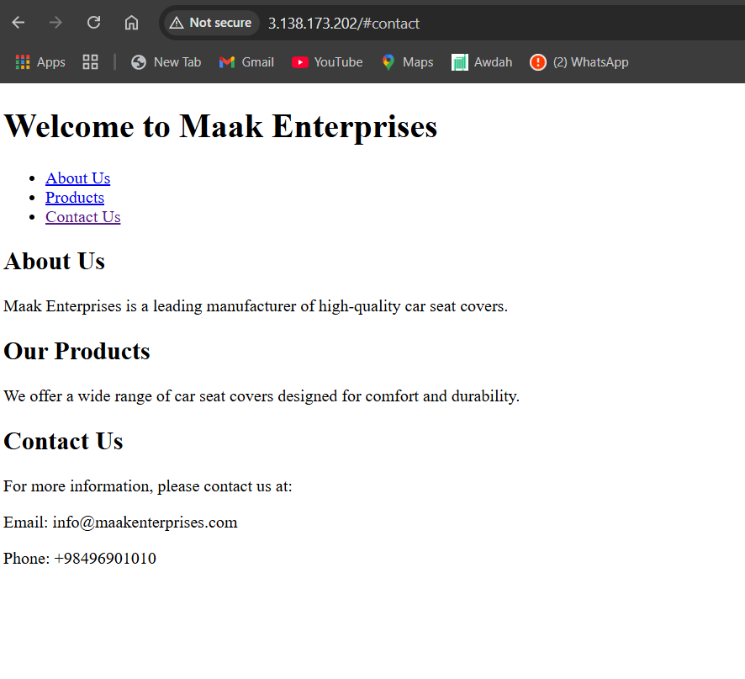

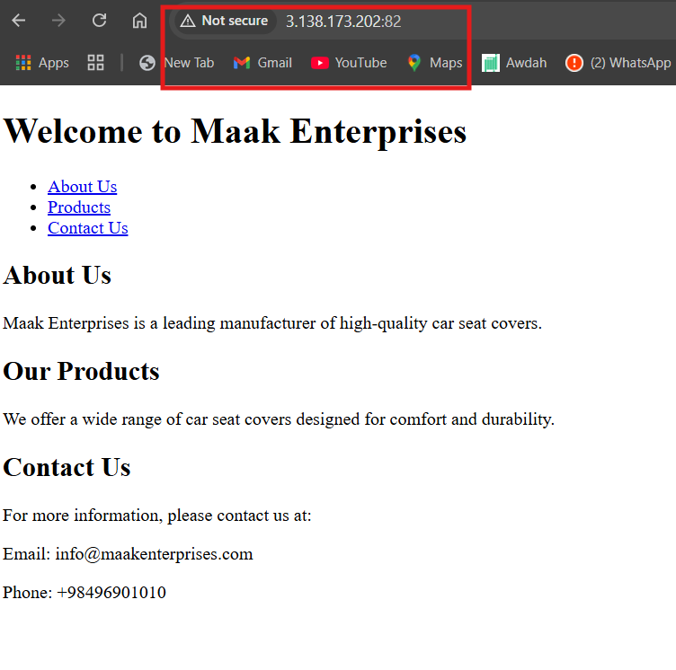

**Application installed in tomcat appche and running**

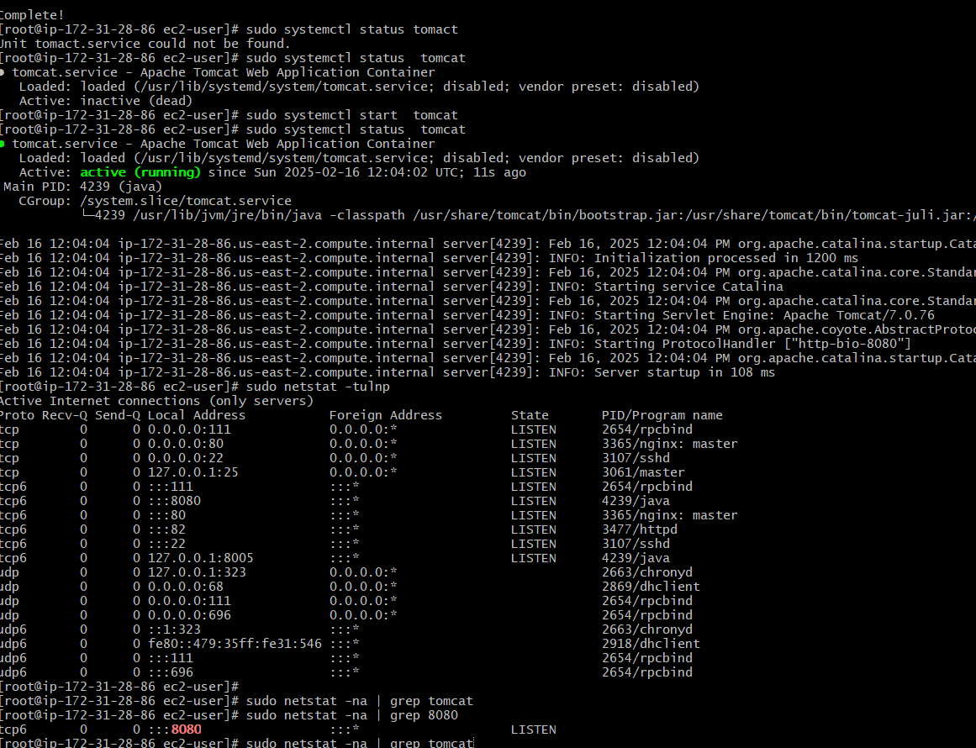

**Install nginx and run nginx on port number 81.**

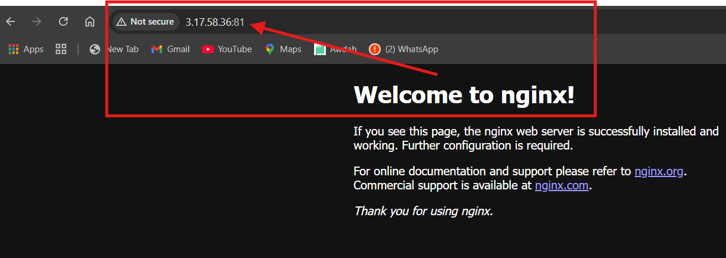

**5) Install Apache tomcat on port number 8082**

**apache-tomcat-9.0.100**

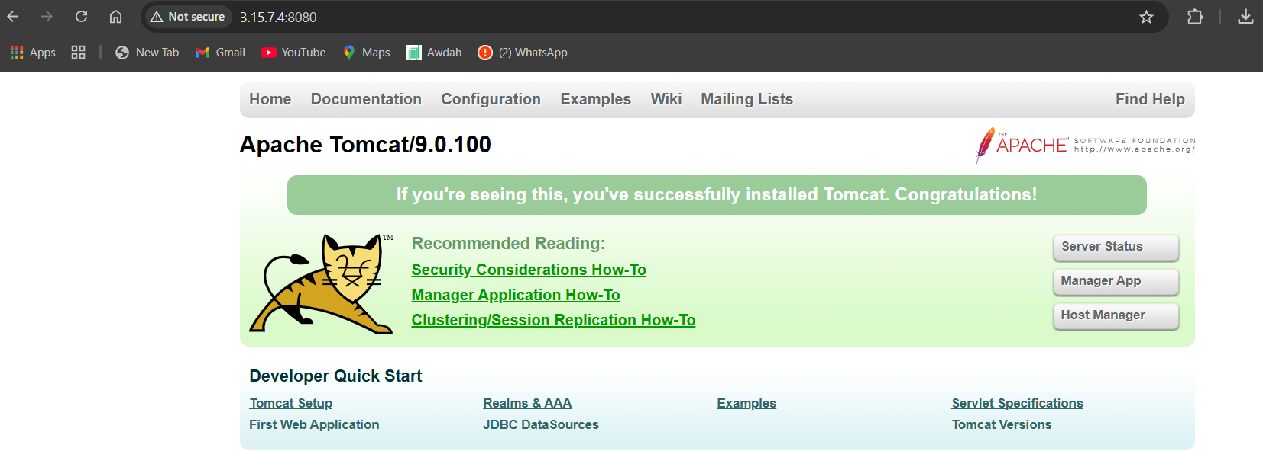

**5) Install Apache tomcat on port number 8082**

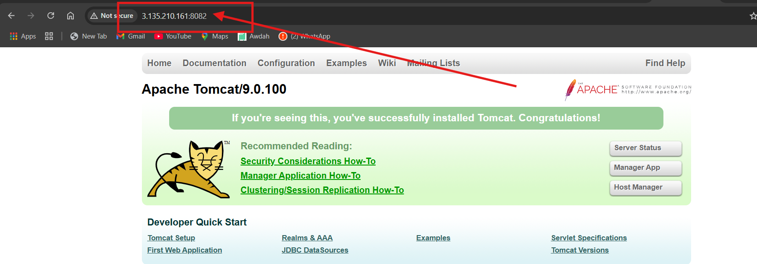

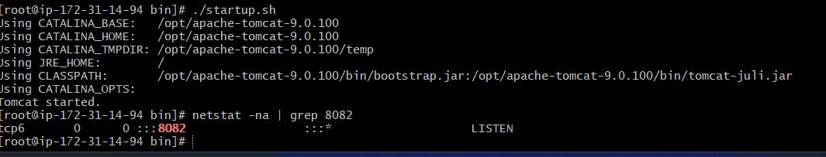

**6) Deploy a sample app on webapps**

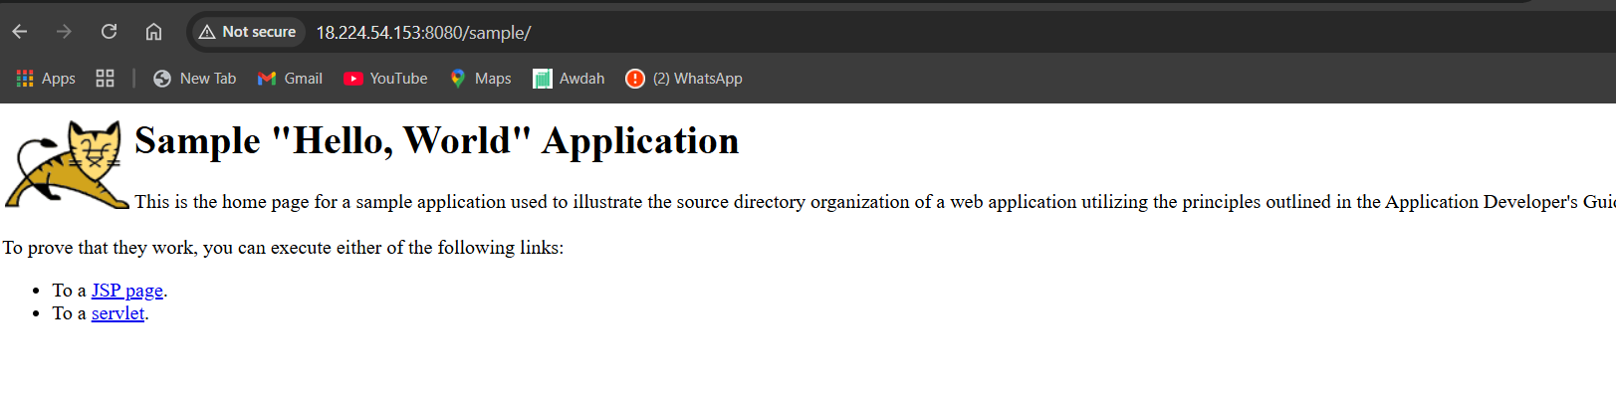

**7) ) Configure HA Proxy server**

